Detection of Freshness/Rottenness of Fruits and Vegetables

**Group Members**

1. Dawit Getahun UGR/9220/13

2. Metsakal Zeleke UGR/1027/13

3. Tinsae Shemalise UGR/6075/13

**Introduction**

In this paper, we will discuss how we built a computer vision system that detects the **Freshness/Rottenness of Fruits and Vegetables**. Classification of fruit and vegetable freshness plays an essential role in the food industry. Freshness is a fundamental measure of fruit and vegetable quality that directly affects the physical health and purchasing motivation of consumers. Most of the quality assurance and defect detections for fruits and vegetables are done by humans. But in a world with a growing emphasis on sustainable, efficient, and highly advanced technologies this is an inefficient and labor-intensive task. With our project, we hope to improve upon the existing system in terms of efficiency and accuracy.

We will first discuss how we collected, cleaned, and prepared our dataset. After that, we will discuss all the different models we tried out and their corresponding results. Finally, we will discuss the mobile app that we built utilizing the system we built, which is one of the many ways our model can be used in the food industry.

**Data Collection**

It is a known fact that for any deep learning project, the amount and quality of data are paramount to the performance of the resulting model(system). In order to build our dataset what first came to mind was to collect the dataset ourselves, but this would require us to dedicate a lot of time and effort. But instead, we looked for open-source datasets from the internet.

After some searching, we found the following datasets:

* [Fresh and Rotten Classification by SWOYAM SIDDHARTHNAYAX](https://www.kaggle.com/datasets/swoyam2609/fresh-and-stale-classification)
* [Fruits and Vegetables dataset by MUKHRIDDIN MUKHIDDINOV](https://www.kaggle.com/datasets/muhriddinmuxiddinov/fruits-and-vegetables-dataset)

# [Classificação de Frutas e Vegetais by PROJETO FV](https://www.kaggle.com/datasets/projetofv/classificao-de-frutas-e-vegetais)

Between the above datasets, we had about 10 fruit and vegetable types. We got to 10 because the datasets had overlapping fruit/vegetable data, so we combined them into one large dataset by either keeping only one of each overlapping fruit/vegetable class or by selectively merging the images into a new fruit/vegetable class. After this process, we had a total of 11986 images belonging to 20 classes, i.e. fresh and rotten for each of the 20 fruit/vegetables.

**Data Cleaning**

Now that we have compiled a big enough dataset we can start to clean the resulting dataset. Most of the images were good but some of them had watermarks and were stock images that don’t reflect what the fruits/vegetables look like. Here are some examples:

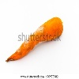 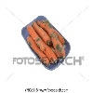

*Fig. 1: Examples of faulty data*

After removing such images, we finished the data cleaning step. We could have resized every image to the same dimensions but it can be done when the data is loaded and trained. That is the best practice while building such systems because putting a resize layer in the network will make our model compatible with any image size plus we won’t need to waste time resizing thousands of images while it can be done during training without that much cost on training time and resources.

**Model Selection and Building**

It is well known that Deep Learning, specifically Convolutional Neural Networks(CNNs) are the best tools that help build different computer vision applications and services. So naturally we decided to use CNNs to help us build our computer vision system.

Currently, there are a lot of CNN architectures we could have chosen from. Besides, libraries like TensorFlow make it easier to build any architecture of our design. Therefore from this point onward, we will discuss the different models we tried out and their performance results.

1. **An architecture we built ourselves**

We first tried to build our own model, mostly to understand how it is done and if needed, to be able to customize the other built-in models later on.

As you can see, in the ***‘training_1.ipynb’*** notebook we have tried to use Max Pooling, and Batch Normalization to combat overfitting and help our model generalize. The performance of the model was as follows:

* **Accuracy: 81%**
* **Precision: 99.9%**
* **Recall: 99.9%**

We have visualized the training and validation loss changes over the epochs, and it shows that our model didn’t overfit and generalized well:

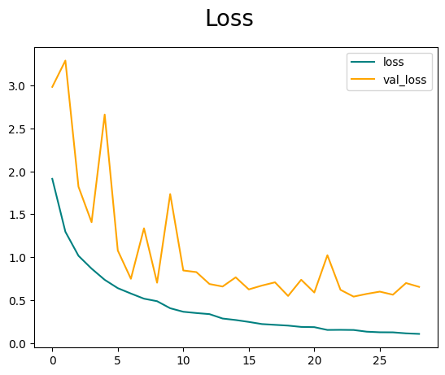

*Fig. 2: Training and Validation Loss progression over the epochs*

Even if the results we got for the model were good we didn’t see those as the result we desired (the model failed to generalize outside of the sample). We saw it as an indicator that other well-designed existing models have so we continued to test out other architectures below.

1. **VGG-16 architecture**

VGG16 is a deep convolutional neural network architecture that was introduced by the Visual Geometry Group at the University of Oxford. It’s characterized by its depth, featuring 16 layers which are depicted in the figure below.

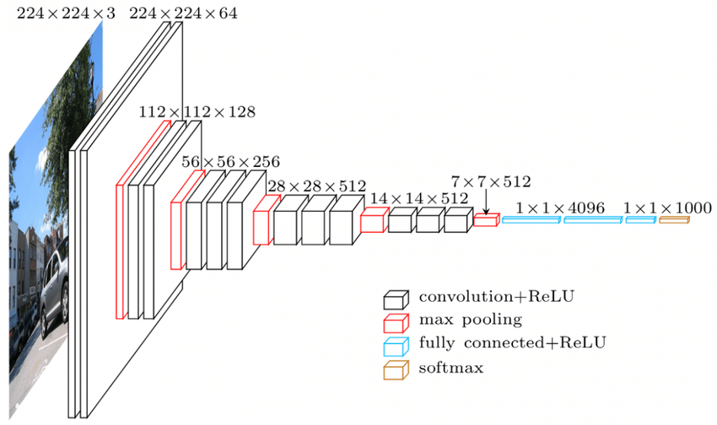

*Fig. 3: Architecture of VGG-16*

Tensorflow provides a built-in implementation of this architecture so all we had to do was feed our data to it. You can find the code for this experiment in the ***‘training_2.ipynb’*** notebook. After training the performance of our model was :

* **Accuracy: 89%**
* **Precision: 99%**
* **Recall: 99%**

We have visualized the training and validation loss changes over the epochs, and it shows that our model didn’t overfit and generalized well within the data sample we compiled:

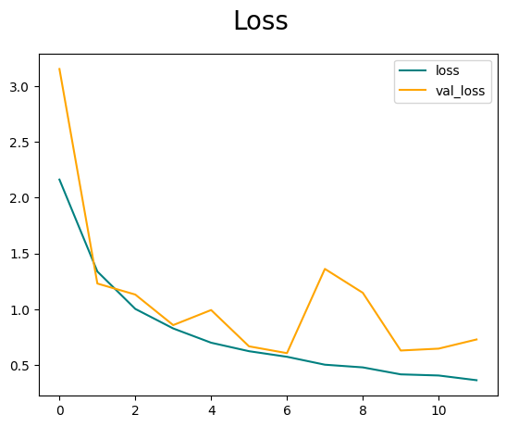

*Fig. 4: Training and Validation Loss progression over the epochs*

But when we decided to test the model on pictures taken from our phones, surprisingly the results weren’t really good. We can see from the validation and training loss that there isn’t any apparent overfitting problem.

So the next thing we tried was to utilize early stopping but nothing changed, our training and testing accuracy stayed pretty much the same. Yet when we tested the model with the photos we took (i.e. real-life data), there wasn’t much improvement.

1. **ResNet - 18 & 50**

ResNet 18 and 50 are two types of convolutional neural networks (CNNs) that use residual blocks to learn deep features from images. Residual blocks are composed of two or three convolutional layers that have a shortcut connection that skips over some layers. This helps to avoid the vanishing gradient problem and improve the accuracy of the network.

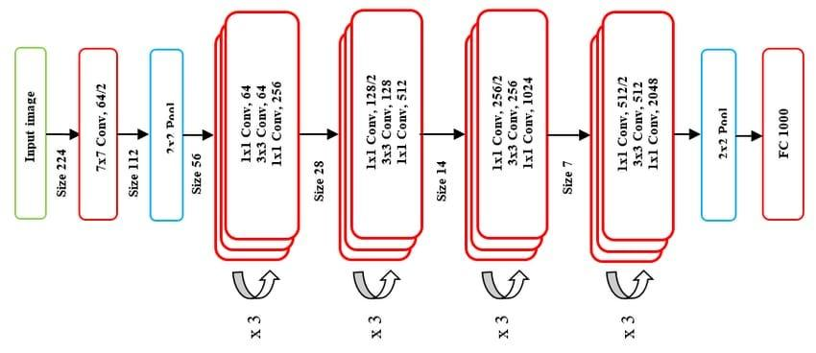

*Fig. 5: Architecture of ResNet*

Again Tensorflow provides built-in implementation of this architecture and the experiment can be found in the ***‘training_3.ipynb’***. The results we got for this architecture were more or less the same. So we felt the need to look for a different strategy, and we opted for building an object detection model rather than an image classification one.

1. **YOLOv8**

YOLO ("You Only Look Once"), a real-time object detection model known for its speed and accuracy, unlike other methods that scan images repeatedly, analyzes the entire image in one go using a single neural network. This network predicts bounding boxes and probabilities for objects within the image, making it efficient for tasks like self-driving cars and video surveillance. And, we opted to use the latest YOLO version, YOLOv8 with faster inference, better precision, and a simpler design for our task.

One challenge was that we could not use the thousands of data we had collected so far as it is to train our model because YOLO requires the bounding boxes for each object in each image to be annotated in a specific format. Luckily we were able to find a YOLOv8 style annotated data from the [Roboflow website](https://universe.roboflow.com/).

* Dataset source:- [found compiled and annotated here](https://universe.roboflow.com/college-74jj5/freshness-fruits-and-vegetables/dataset/7#).
* Scope of data:- Focus on a small-scale implementation, concentrating on specific varieties of fruits and vegetables commonly found in local markets. (Oranges, Mangoes, Bananas, Apples, Cucumbers, Carrots, Potatoes)

Reasons for switching to YOLOv8 rather than the models we have been trying earlier are mainly bad performance on unseen, real-life data and poor generalizing capabilities. So basically we found ourselves at a crossroads shifting the scope of this project to include live object detection. And because of its single-shot detection capability, we found YOLO to be more suitable than other techniques like the sliding-window method.

Training with YOLO:

* Input: The dataset has to be prepared in a unique format. A text file containing the class of the object, the coordinates of the center of the object, and its dimensions (height and width)
* Output: A model capable of detecting an object from any image, labeling it based on the training data, and drawing its coordinates.

**Previous Work with YOLOv4**

In October 2022, the [Department of Computer Engineering at Gachon University, South Korea,](https://www.mdpi.com/1424-8220/22/21/8192) undertook a comprehensive exploration of the limitations associated with YOLOv4 in the context of food quality control.

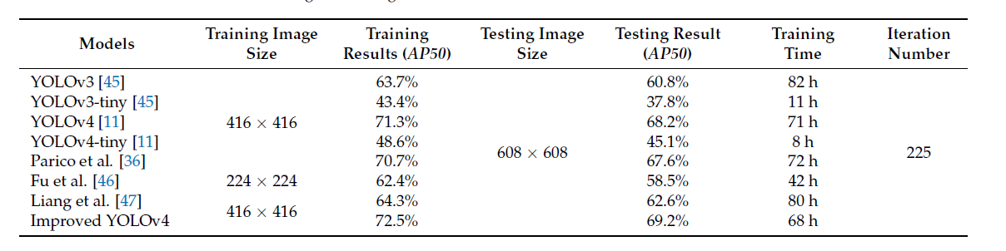

*Fig 6. Figure showing the results obtained from the researchers from Korea in table format*

Our team faced limitations in terms of both time and resources during the experimentation with YOLOv8. The use of Google's free GPU access, with a maximum allowance of 12 hours per day, posed a constraint. Additionally, frequent interruptions due to internet connectivity issues curtailed our training sessions, limiting us to only 50 epochs compared to the extensive 225 epochs undertaken by the Korean researchers. Furthermore, our uninterrupted training time was a mere 2 hours, in stark contrast to the 80 hours achieved by the researchers mentioned above.

**Results with YOLOv8**

Nonetheless, the results we managed to achieve were promising. The mean average precision at 50% Intersection over Union (mAP50), a critical metric measuring the overlap between predicted and ground truth bounding boxes, exhibited encouraging signs. Our training mAP50 reached an impressive 88.2%, showcasing the effectiveness of YOLOv8. During testing, the model maintained a strong mAP50 score of 63.6%.

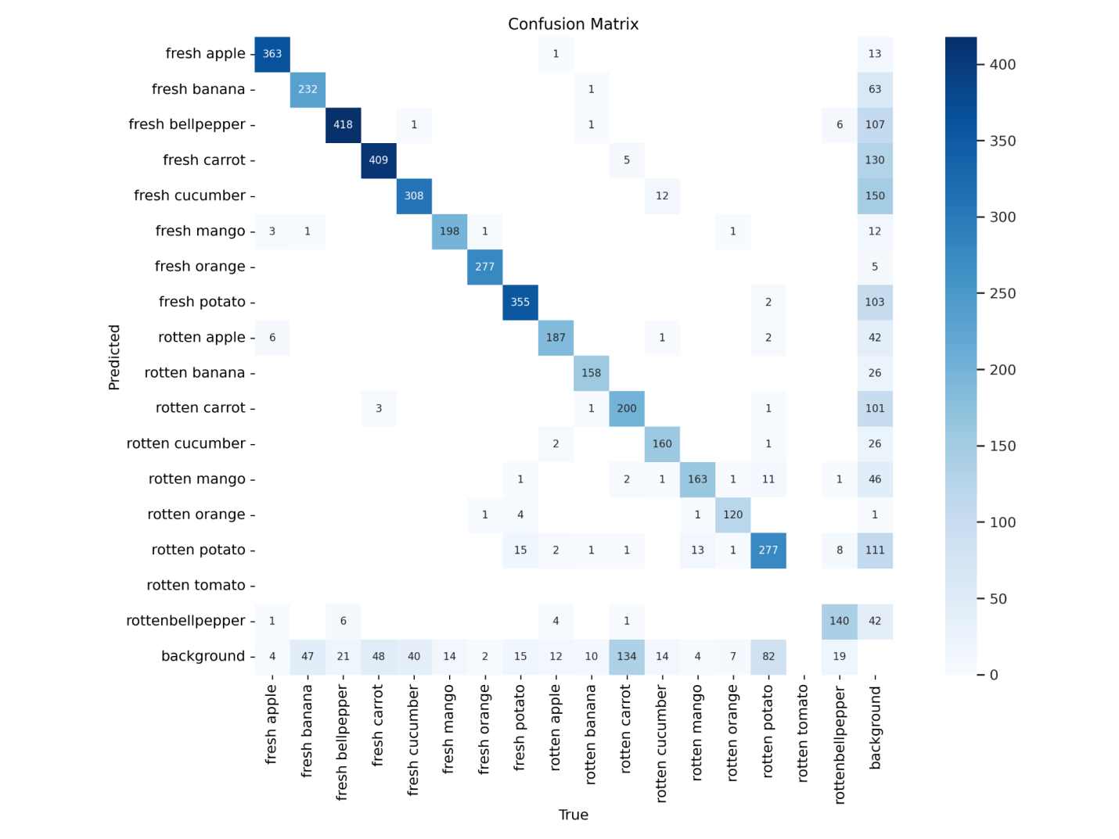

*Fig 7. Figure showing the confusion matrix obtained after the first 25 epochs.*

The confusion matrix for our model shows that, while having good accuracy in accurately identifying fresh products, it also excels in minimizing false positives for fresh products. However, challenges arise when dealing with rotten or stale products, where the model tends to struggle to accurately distinguish them.

**Trained Model Utilization**

Now that we are done with building the model, we would like to utilize it to showcase how one of its applications would look like. To do this we created a simple mobile app that allows you to do object detection from your live camera feed, take pictures, or choose a picture from your gallery and determine whether the picture contains fruits/images and also tell if they are rotten or fresh.

Since our final model was built not just for image classification but for object detection, we can detect different types of fruits/images within an image and individually determine whether they are fresh or rotten. The only thing to take note of is that the images we take should be a little bit up close and have good lighting and quality. The source code for the app can be found [here](https://github.com/dawit-getahun-mengistu/fruits_and_vegetables_object_detection). Currently, the app is only for Androids, because one of the key dependencies used for model inference (the flutter package [flutter_vision](https://pub.dev/packages/flutter_vision)) has not been made available for IOS devices yet.

Below are screenshots of the app layout:

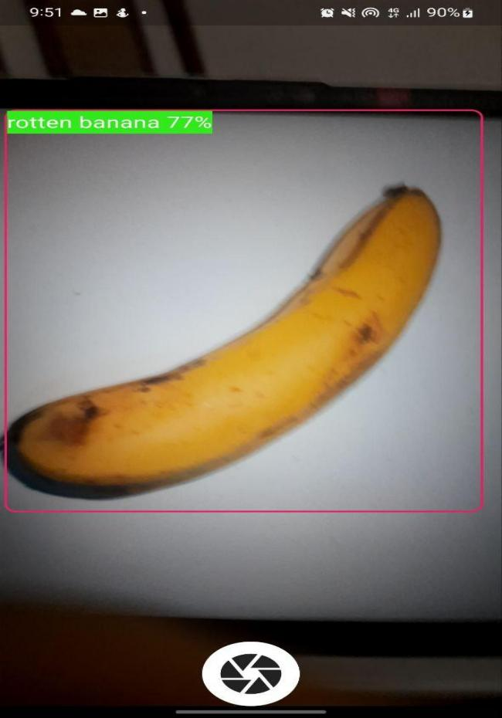 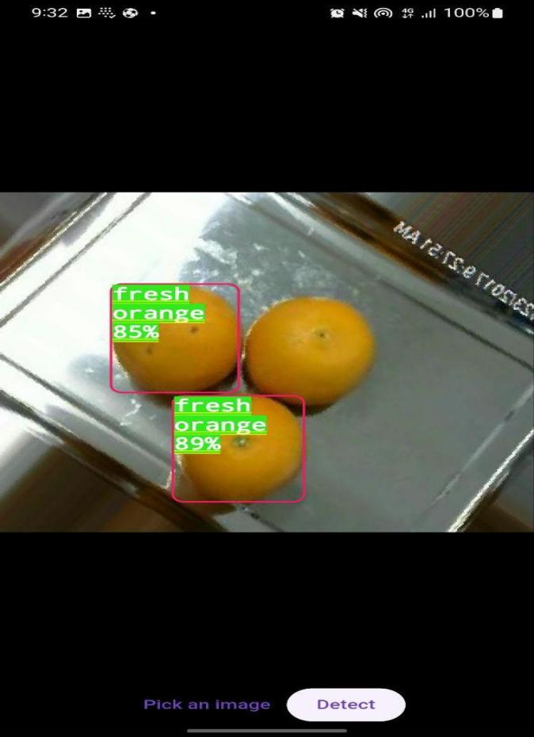

*Fig. 8: Screenshots of our app. On the left is a screen that allows us to detect fruits/vegetables from the camera feed, and on the right from the gallery. The boxes are drawn on the detected fruits or vegetables with their respective confidence score*

**Conclusion**

The findings suggest that implementing our proposed system, built on the foundation of YOLOv8, has the potential to enhance existing food quality control measures in Ethiopia, provided adequate resources are available. Moreover, the system can be extended to include other locally-grown and widely consumed products such as onions, tomatoes, papayas, etc. Furthermore, the applicability of this system extends to other agricultural products, such as coffee, a significant contributor to the country's exports, and teff.

This comparative analysis underscores the adaptability and potential impact of YOLOv8 in advancing object detection capabilities for agricultural and food quality control applications.

**References**

1. Mukhiddinov, M.; Muminov, A.; Cho, J. Improved Classification Approach for Fruits and Vegetables Freshness Based on Deep Learning. *Sensors* **2022**, *22*, 8192. <https://doi.org/10.3390/s22218192>
2. Bhargava, A.; Bansal, A. Fruits and vegetables quality evaluation using computer vision: A review. *J. King Saud Univ. Comput. Inf. Sci.* **2021**, *33*, 243–257. [[Link](https://www.sciencedirect.com/science/article/pii/S131915781830209X?via%3Dihub)]